
Egypt University of Informatics
Computer and Information Systems
Data Analysis Course

The Effect of Music on Focus and Productivity While Studying

  - Submitted by: Roaa Yasser 24-101384
10/4/2026

Introduction

Many students listen to music while studying. It has become a very common habit, especially during long study sessions. But does music actually help students focus or does it make things worse? This is something people still disagree on.
This report looks at how music affects students' focus and productivity. We asked students how often they listen to music while studying, what type of music they prefer, and whether they feel more or less productive with it. The goal is to understand these habits better.

Research Question
Does listening to music while studying affect how focused, productive, and stressed students feel?

Hypothesis
We think that students who listen to instrumental or low-lyric music will feel more productive compared to those who listen to rap or pop. We also think that listening to familiar music will be less distracting than listening to new songs, because familiar songs don't require as much attention.

Population of Interest
Our target group is university students, mostly between 18 and 21 years old, who regularly do focused academic work like studying, coding, or writing. Most of our respondents are students at Egypt University of Informatics (EUI).

Sampling Method
We used convenience sampling, which means we shared a Google Form link through CIS student group chats and collected whoever was willing to respond. We got 61 responses in total. This method is simple and easy to use, but it does mean not everyone had an equal chance of being included.

Bias Identification
We tried to think about what could affect the results in an unfair way. Here are a few things we noticed:
Some people might say they are more productive with music than they actually are, just because it sounds better. We used number scales to make answers more honest.
Students who have strong feelings about music are more likely to fill out the survey, which means the results might not represent everyone equally.
Some questions ask about habits, so people had to try to remember what they usually do. This kind of memory can sometimes be off.

Survey Questions
The following questions were included in the online survey:
1. What is your age group?
2. What is your gender?
3. How many hours a day do you spend on deep-focus tasks (studying, coding, writing)?
4. How often do you study while listening to music?
5. What type of music do you usually listen to while studying?
6. Do you prefer familiar or new music while working?
7. What kind of tasks do you prefer doing with music?
8. What is your preferred environment for maximum focus?
9. How productive do you feel when studying with music? (1–5 scale)
10. I often find myself actively listening (singing/tapping) instead of working. (1–5 scale)
11. Background music prevents me from being distracted by outside noises. (1–5 scale)
12. Does music reduce your stress while studying?

Online survey link: https://forms.gle/BnbZxmPnwYPbXhJ5A
Number of samples collected: 61

Analysis

The central tendency of the data suggests a remarkably consistent of productivity across the student population, with all major metrics converging around the middle of the scale(1–5 scale):

- Mean (Average): 3.08
- Median (Middle): 3.00
- Mode (Most Common): 3.00

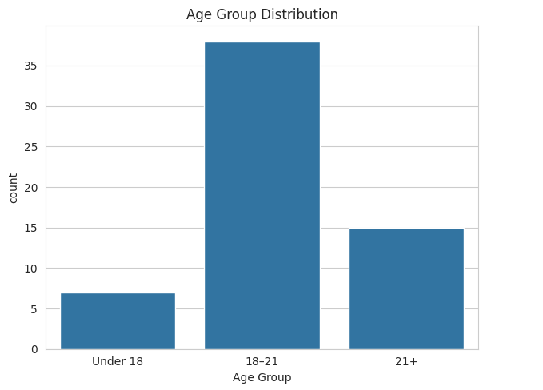
The chart shows that 37 out of 61 respondents (60.7%) fall in the 18–21 age group, with the next largest group being 22–25 years old at 14 respondents (23.0%). This shows that the majority of respondents are traditional university age, making the sample relevant for studying student habits.

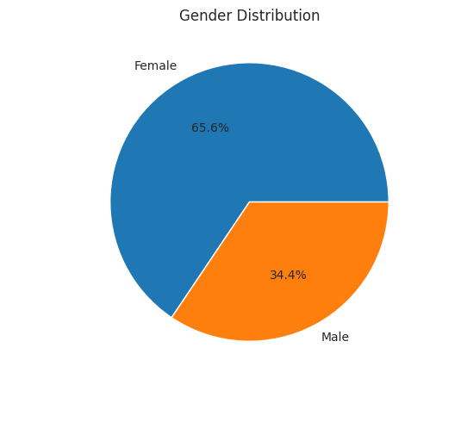
The chart shows that 65.6% of respondents are female and 34.4% are male. This indicates a gender-skewed sample where female voices are overrepresented compared to the general student population.

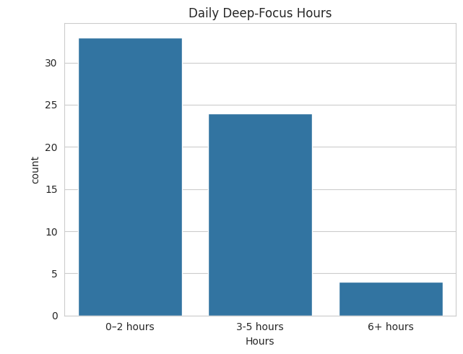
The Bar chart shows that 32 respondents (52.5%) report only 0–2 hours of deep-focus work per day, while only 4 respondents (6.6%) report 6+ hours. This suggests that most students in this sample do not engage in long, sustained study sessions.

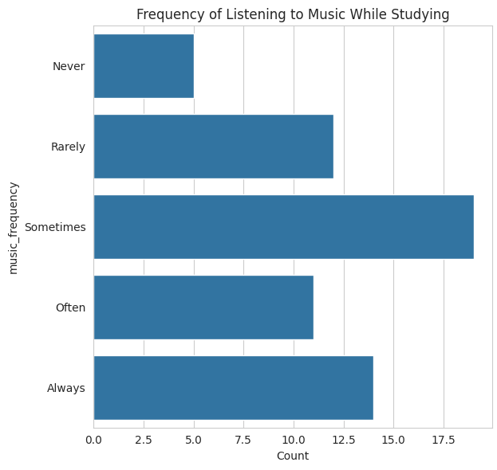
The bar chart shows that most respondents selected "Sometimes," "Often," or "Always," with very few selecting "Never" or "Rarely." This indicates that listening to music while studying is a common habit for the vast majority of students in this sample. This confirms that music is deeply embedded in this generation's study routine, making it essential to understand its actual impact on focus

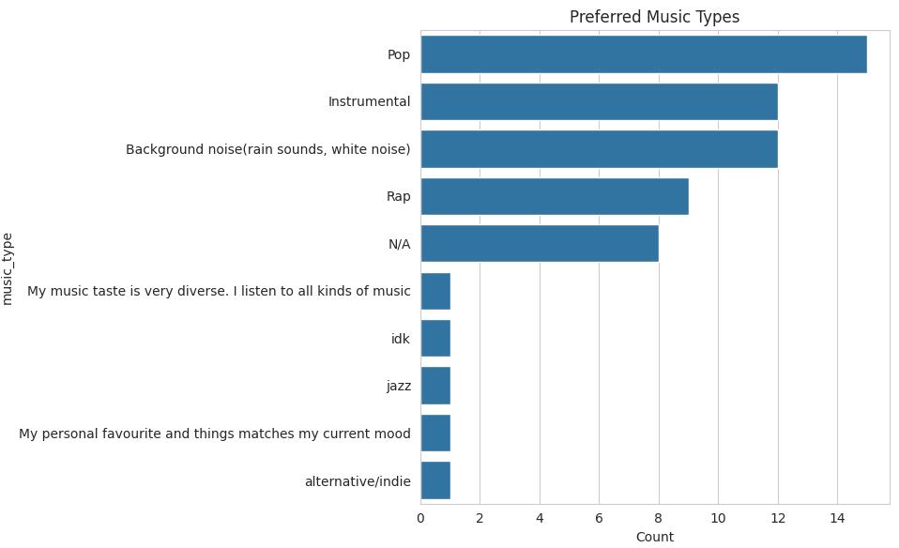

Bar Chart Showing Students’ Preferred Music Genres. The bar chart shows that Rap is the most selected genre, followed closely by Pop, while instrumental and lo-fi genres have fewer selections. This shows that students prefer lyric-heavy music despite the potential for verbal distraction.

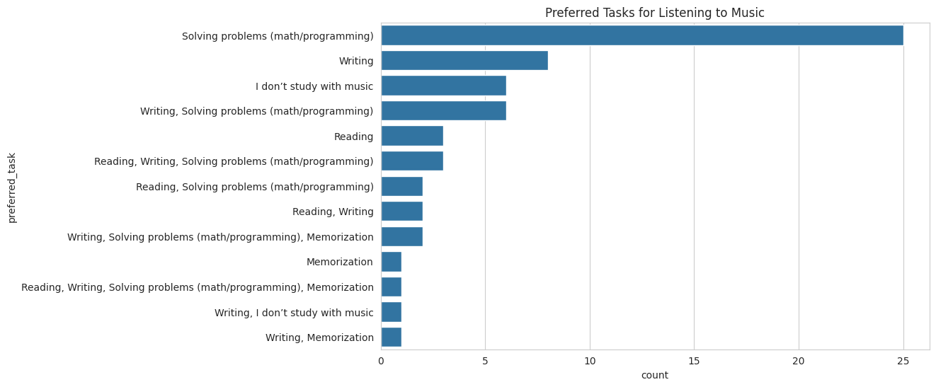

The bar chart shows that Reading has the highest number of responses, followed by Writing, then Coding, with Math and problem-solving having the fewest. This suggests that students naturally pair music with lighter cognitive tasks and reduce it during high-demand analytical work, reflecting an intuitive self-regulation behavior where the difficulty of the task drives their music choices.

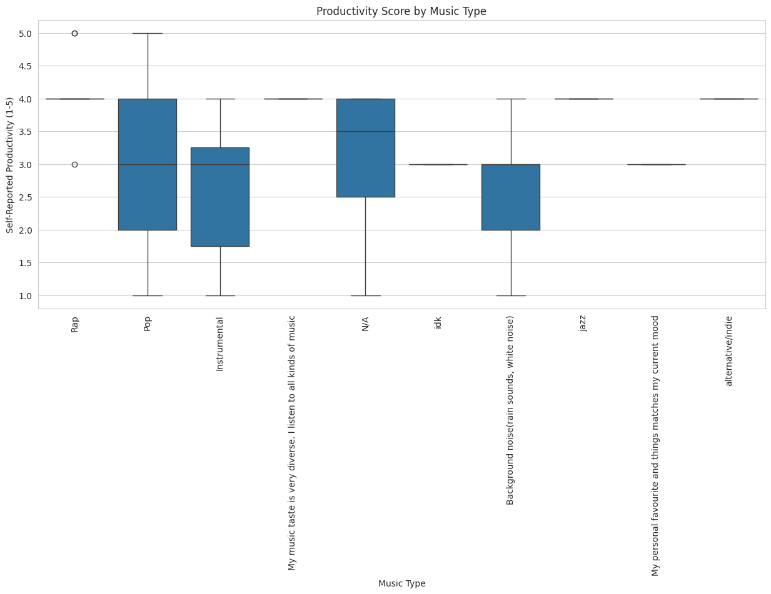
The box plot displays productivity scores across six music genres, revealing that while the median score for all types is consistent at 3, the distribution of these scores varies significantly. Rap and Pop exhibit the greatest spread, with interquartile ranges spanning from 2 to 4 and whiskers reaching the full scale from 1 to 5, whereas Instrumental show much tighter concentration around the median.

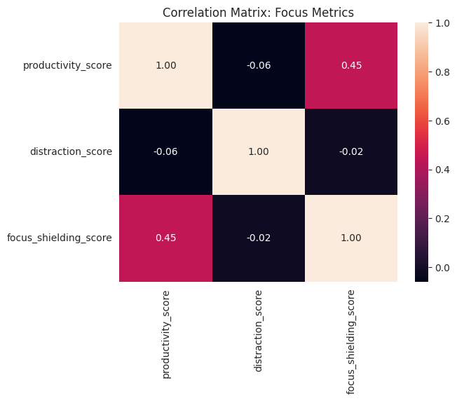
The scatter plot matrix shows three focus metrics compared against each other: productivity, distraction, and focus shielding. Each metric is plotted against the other two, creating three separate scatter plots. Each point represents one respondent. In all three plots, the points are scattered widely without forming a clear diagonal line. The distribution appears random across all comparisons.

Conclusion
Based on the 61 responses we collected, music is something most students use while studying — over 90% listen to it at least sometimes. However, the impact on productivity is mixed. The average productivity score was 3.08 out of 5, meaning music does not make a huge difference for most people.
Our hypothesis was partially supported. Instrumental and background noise music were quite popular, and these types are generally seen as less distracting. But we cannot say for sure that they lead to better results without measuring actual grades.
One interesting finding is that most students prefer silence when they really need to focus, even though they still listen to music regularly. This might mean that music is more of an emotional habit — something that makes studying feel more comfortable — rather than something that directly improves performance. The fact that 78.6% said music helps with stress supports this idea.

Potential Issues
Here are some problems we noticed with our data collection:
1. We only had 61 responses, which is a small number. The results might look different with more people.
2. We used convenience sampling, so only students who saw our link and chose to respond filled it in. This may not fully represent all students.
3. The productivity scores are based on how people feel, not on actual grades or test results. Two people might mean different things by the same score.
4. We did not measure real academic performance, so we cannot say for sure whether music improves grades or not.
5. A few responses had unusual answers in open text fields (for example, an Arabic artist name), which required extra cleaning.

